43.65: a) 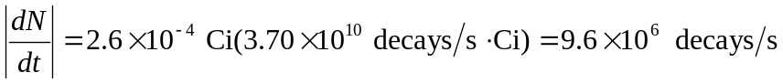 so in one second there is an energy delivered of
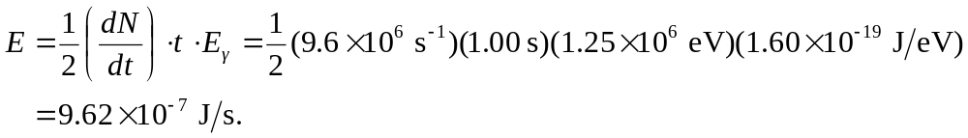
b) Absorbed dose 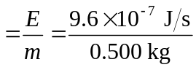
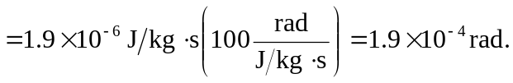
c) Equivalent dose 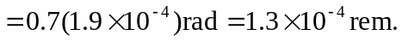
d) 